Experiment No. 3

Aim: To study various types of Multiplexer and Demultiplexer and its practical applications.

# Objectives:

1. To study different types of multiplexers (2:1, 4:1, 8:1,..etc) and demultiplexers (1:2, 1:4, 1:8,...etc).
2. To understand internal circuit diagram of various multiplexer and demultiplexer ICs and its specifications.
3. To verify the truth table of MUX and DEMUX by applying various input combinations and check the desired output. Also understand real / practical applications of MUX and DEMUX.
4. To understand different multiplexer and demultiplexer ICs and implementation/ realisation of various digital circuits using the same.

Also design and implement various circuits using MUX and DEMUX.

# Equipment:

Multiplexer and demultiplexer ICs (74151), 5VDC regulated power supply, bread board, connecting wires, LED, DMM, etc.

# Theory:

## Multiplexer

Multiplexer means “many to one”. It is a device that selects one of several [analog](http://en.wikipedia.org/wiki/Analog_signal" \o "Analog signal) or [digital](http://en.wikipedia.org/wiki/Digital_signal) input signals and forwards the selected input into a single line. The multiplexer has several data input lines and a single output line. The selection of a particular line is controlled by a set of selection lines. There are 2n input lines and n selection lines whose bit combinations determine which input is selected. Based upon the number of inputs we have different types of multiplexers like 2:1, 4:1, 8:1, 16:1...etc.

### 4:1 MUX:

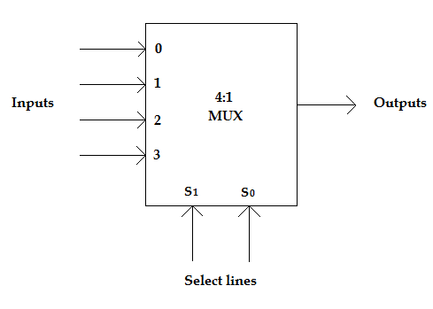

### Truth Table:

|  |  |  |
| --- | --- | --- |
| S1 | S0 | Y |
| 0 | 0 | D0 |
| 0 | 1 | D1 |
| 1 | 0 | D2 |
| 1 | 1 | D3 |

### Tree Configuration for multiplexer:

Two or more than two multiplexers can be cascaded as shown in the fig. when large no. of signals are to be passed. Here select lines are connected in parallel and the enable line is connected directly to one multiplexer and its complement is connected to the other multiplexer. Thus only one multiplexer is enabled at a time.

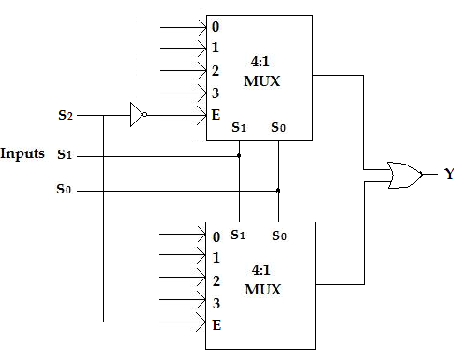

## Demultiplexer:

A demultiplexer is a circuit that receives information on a single line and transmits this information on one of 2n possible output lines. The selection of specific output line is controlled by the values of n selection lines. Depending upon no. of outputs required various types of demultiplexers like 1:2, 1:4, 1:8, …..etc are available.

### 1:4 DEMUX:

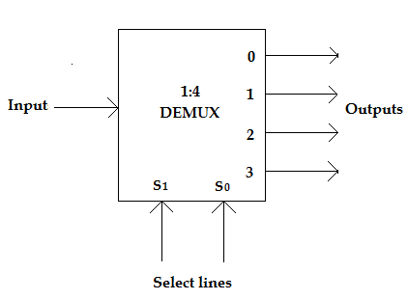

### Truth Table:

|  |  |  |  |  |  |
| --- | --- | --- | --- | --- | --- |
| S1 | S2 | Y3 | Y2 | Y1 | Y0 |
| 0 | 0 | 0 | 0 | 0 | 1 |
| 0 | 1 | 0 | 0 | 1 | 0 |
| 1 | 0 | 0 | 1 | 0 | 0 |
| 1 | 1 | 1 | 0 | 0 | 0 |

### Tree configuration for demultiplexer:

The cascading of demultiplexers is same as cascading of multiplexers. Two or more than two demultiplexers can be cascaded as shown in the fig. below. Here select lines are connected in parallel and the enable line is connected directly to one demultiplexer and its complement is connected to the other demultiplexer.

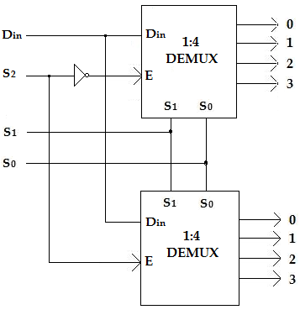

## Practical application of Multiplexer:

In [telecommunications](http://en.wikipedia.org/wiki/Telecommunications) and [computer networks](http://en.wikipedia.org/wiki/Computer_networks), multiplexing is a method by which multiple analog message signals or digital data streams are combined into one signal over a [shared medium](http://en.wikipedia.org/wiki/Shared_medium).  For example, in telecommunications, several [telephone calls](http://en.wikipedia.org/wiki/Telephone_call) may be carried using one wire.

Also, multiplexers are widely used in film industry where multi camera set-ups are used. Out of the n cameras only one of the camera output is selected at a time.

## Practical application of Demultiplexer:

Demultiplexing is used very often in telecommunication for transmitting a singal message to a large no. of channels. For eg. In radio broadcasting the contents at the radio station are transferred to many other channels via cables. In this demultiplexer is used.

# Logic Diagram (Design):

## 2to1MUX

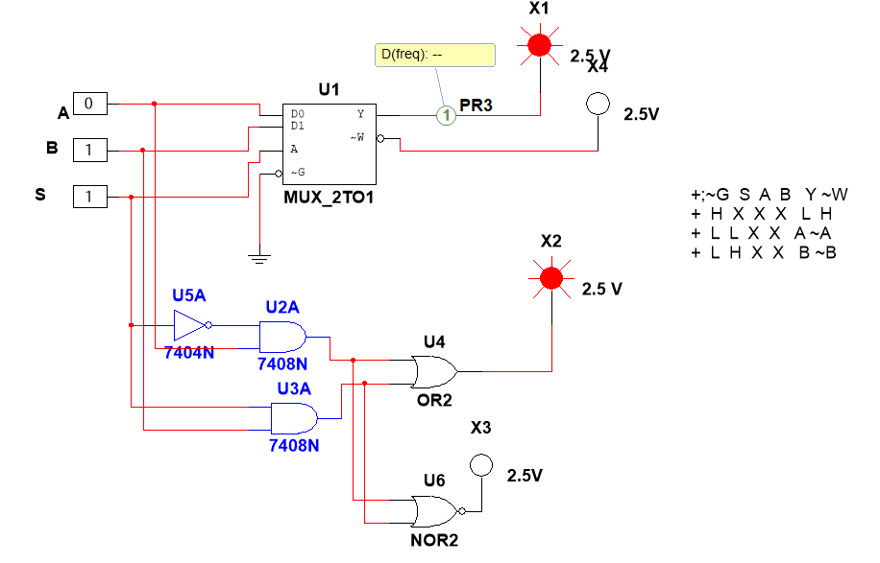

## 4to1MUX

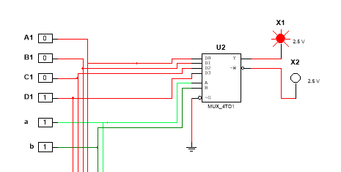

**4:1 mux using logic gates**

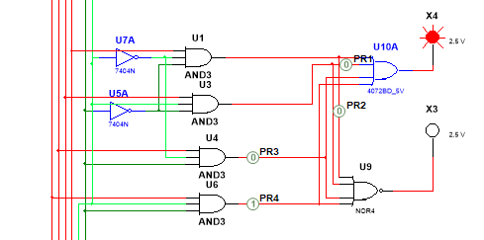

**4:1 mux using cascading of 2:1mux**

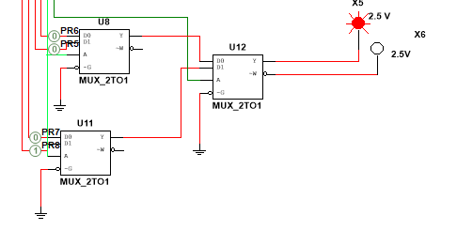

## 8to1MUX

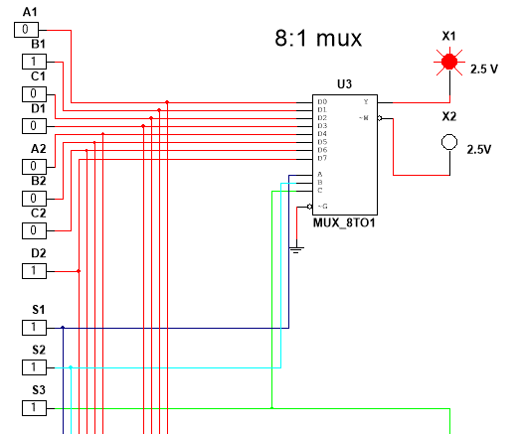

**8:1 mux using cascading of 4:1 mux** 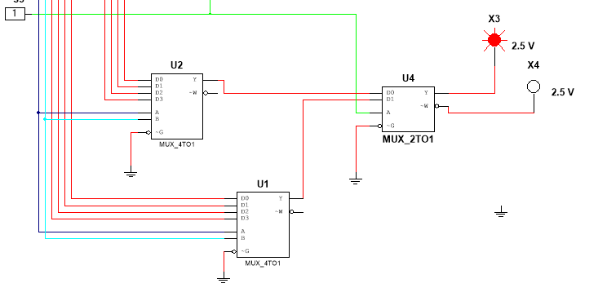

## 1to2DEMUX

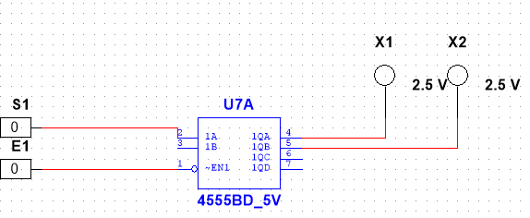

## 1to4DEMUX

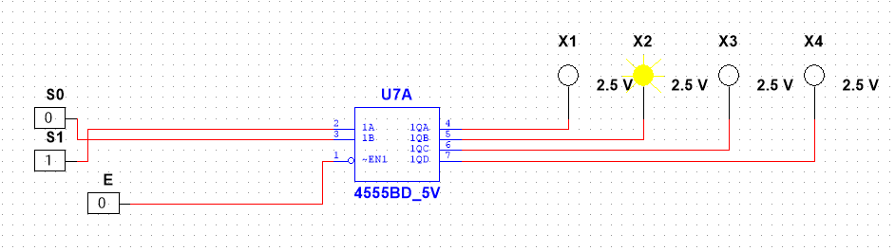

## 1to8DEMUX

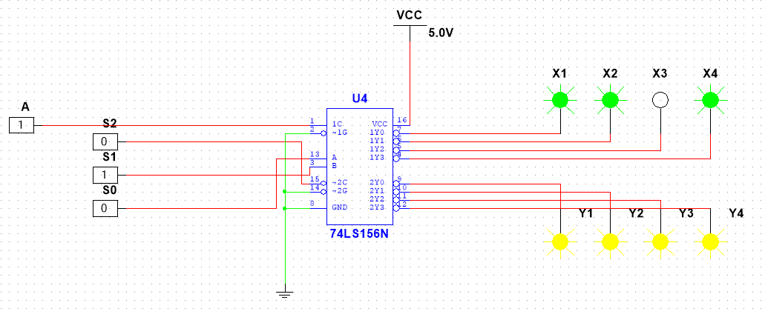

# Procedure:

1. Connect the components as shown in the circuit diagram.
2. Give +5V supply to the IC’s.
3. From the LED observe the outputs.
4. Make a note of the truth tables in the observations.
5. Verify the truth tables accordingly.

# Observations:

## 2to1MUX

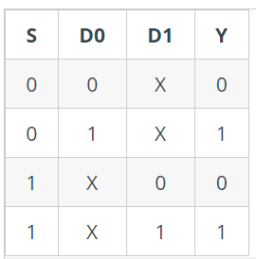

## 4to1MUX

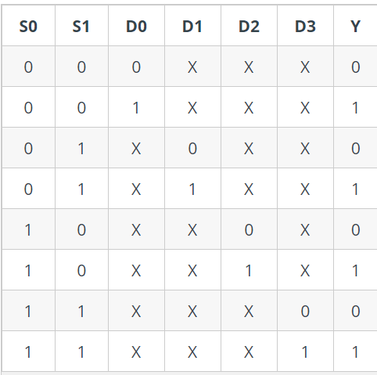

## 8to1MUX

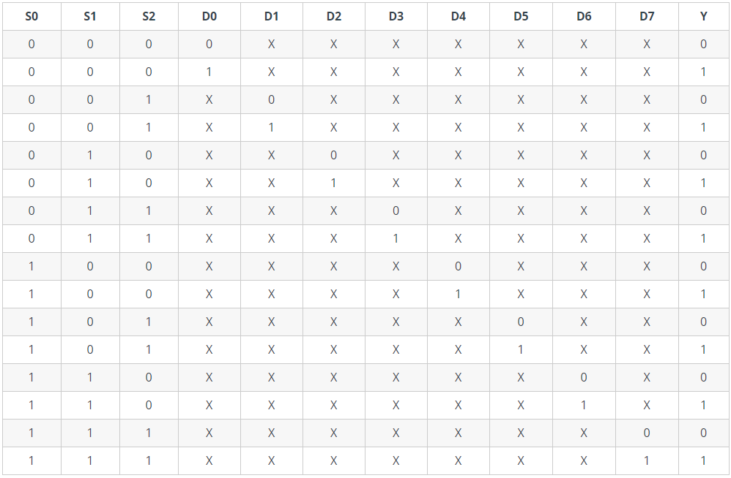

## 1to2DEMUX

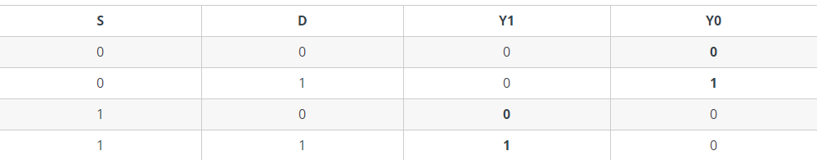

1TO4DEMUX

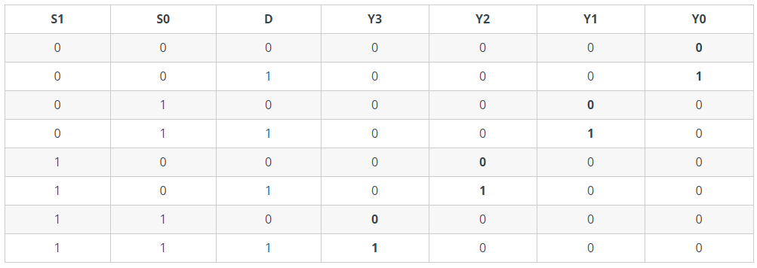

## 1to8DEMUX

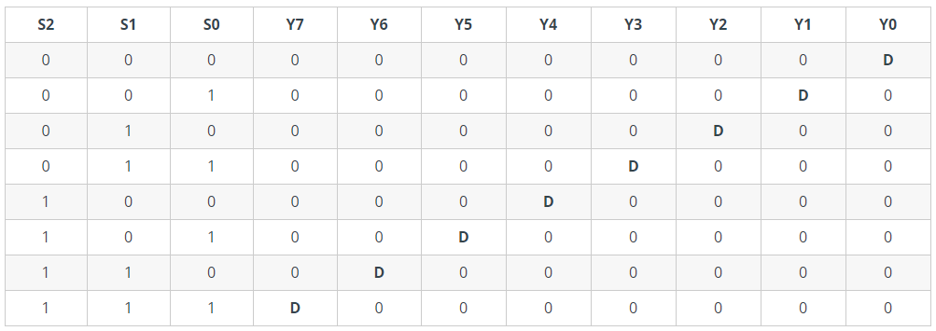

# Result:

Above mentioned circuits were created and run in multisim software**.**

# Conclusion:

Truth tables were verified by simulating the created circuit.

# What did you learn?

I learnt how mux demux circuits are made by using ics and gates, and I understood their working by simulating them and verifying the truth table.

**Learnt that we can also build mux by cascading other multiplexers.**

**I learnt TTL ICs for mux and demux as**

**74153 – 4:1 mux**

**74ls151- 8:1 mux**

**4555BD – 1:4 demux**

**74ls156 – 1:8 demux**

# Assignment:

## IMPLEMENTATION OF MUX

Used in PISO register for selecting input to be applied.

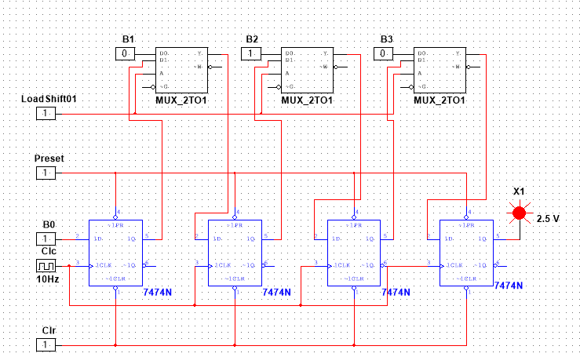

THANK YOU!